

**Name: Aly Mohamed Maamoun**

**Email:** [**aly.mammoun18@gmail.com**](mailto:aly.mammoun18@gmail.com)

**Topic: EDF schedular with FreeRTOS**

# **Table of timing**

|  |  |  |  |  |
| --- | --- | --- | --- | --- |
| task | Periodicity | Deadline | Occurrence during hyperperiod | Execution time |
| Button 1 | 50ms | 50ms | 2 | 30us |
| Button 2 | 50ms | 50ms | 2 | 30us |
| Periodic transmitter | 100ms | 100ms | 1 | 94us |
| UART | 20ms | 20ms | 5 | 140us |
| Load 1 | 10ms | 10ms | 10 | 5ms |
| Load 2 | 100ms | 100ms | 1 | 12.5ms |

# **System hyperperiod:**

Hyperperiod of any system is the least common multiplier for all the periodicities of the tasks

Hence, hyperperiod here is 100 ms

# **CPU load:**

Utilization = total execution time/hyperperiod

Utilization = 2(30u)+2(30u)+1(94u)+5(140u)+10(5m)+1(12.5m)/(100m)

Utilization = 63.414%

# **System Schedulability**

# **Rate monotonic**

- Utilization = 63.414%

- Number of tasks= 6

U < n(2 ^(1/n) – 1)

If yes then system is schedulable

0.63 < 0.73

system is schedulable

## **Time demand**



Worst case is in the time 100ms

After sorting the table , we will do analysis for the 6 tasks by sorting them ascendingly on periodicity

|  |  |  |
| --- | --- | --- |
| Task | Equation and result | schedulable? |
| Load 1 | W1(10)=5m+0=5m  5<10 | yes |
| UART | W2(20)=140u+(20/10)5m=10.14m  10.14<20 | yes |
| Button 1 | W3(50)=30u+(50/20)140u+(50/10)5m= 25.31m  25.31<50 | yes |
| Button 2 | W4(50)=30u+(50/50)30u+(50/20)140u+(50/10)5m=25.34m  25.34<50 | yes |
| Periodic | W5(100)=(100/50)30u+(100/50)30u+(100/20)140u+(100/10)5m+94u =50.914m  50.914<100 | yes |
| Load 2 | W6(100)=(100/50)30u+(100/50)30u+(100/20)140u+(100/10)5m+94u+12.5=63.414m  63.414<100 | yes |

# **Screen shoots from simulators**

## Simso

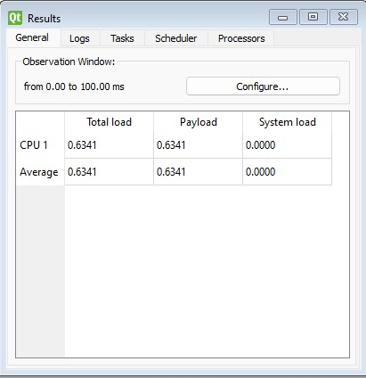

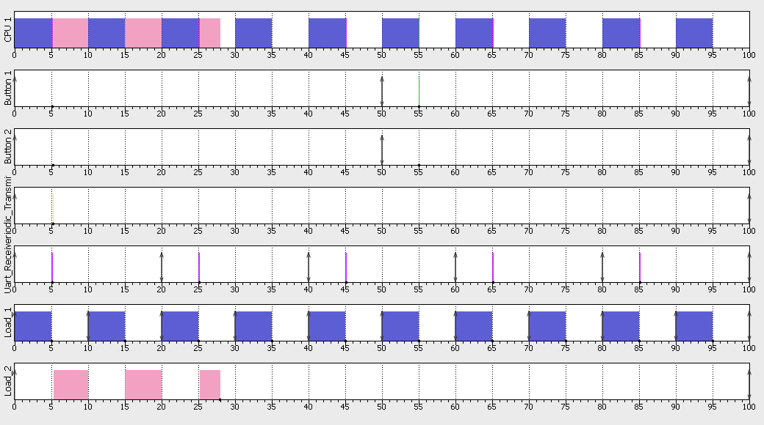

## Keil

